**Immediate Animal Recognition and Anticipation Classification for Harvest Fields Using Machine Learning Techniques**

**RESEARCH BASED LEARNING**

**COMPUTER SCIENCE AND ENGINEERING**

**(DATA SCIENCE)**

By

**BILLA NITHYA REDDY -20951A6726**

**THALAPAKA SHIVANI -20951A6743**

Under the guidance of

**Chief Mentor: Dr. Laxmi Prasad**

**Co-Ordinator Name: Ch.Sreenivasulu**



**Immediate Animal Recognition and Anticipation Classification for Harvest Fields Using Machine Learning Techniques**

M. Lakshmi Prasad1, Ch.Srinivasulu2, B. Nithya Reddy3 and T.Shivani4

1Associate Professor, Department of CSE (DS), Institute of Aeronautical Engineering, Hyderabad

2Professor, Department of CSE, Institute of Aeronautical Engineering, Hyderabad

3Department of CSE (DS), Institute of Aeronautical Engineering, Hyderabad

**ABSTRACT**

An automatic electronic human eye was designed which helps to sense the presence of humans. Concept behind Automatic Electronic Human Eye is that we usually have pet dogs stationed at the entrance and the purpose of the dogs is that they bark whenever a person enters through the door. So the concept behind this project is to perform the same task of detecting the presence of a person at draining crop area. The ultrasonic sensor is a sensor which detects the 3600 angle, its waves have wavelength of 1.9cm or less and sounds frequently greater than 20KHz, when someone interrupt our drying crop area (or) when animals try to consume the crop, the crops on the road are interrupted, then we get the intimation or sends a message to phone through GSM (Global System for Mobile communication). By that intimation the owner of the crops can come to know that their crops were interrupted.

**Keywords:** Machine Learning, Object Detection, Sensing, GSM Module, Image processing, Classification

**1. INTRODUCTION**

Framers usually work for six months to get the crop but last 10days are very important for the farmers to dry and sell their crop. So, while drying it the farmers may lose their crop due to animals.

GSM or Global System for Mobile Communication is a Wireless Communication standard for mobile telephone systems. It was developed by the European Telecommunications Standards Institute (ETSI) as a replacement to the 1st Generation Analog Cellular Network.

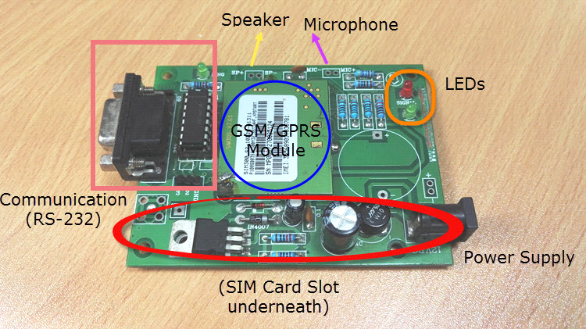

Fig 1.1 GSM Module

An ultrasonic sensor is an electronic device that measures the distance of a target object by emitting ultrasonic sound waves, and converts the reflected sound into an electrical signal. Ultrasonic waves travel faster than the speed of audible sound (i.e. the sound that humans can hear). Ultrasonic sensors have two main components: the transmitter (which emits the sound using piezoelectric crystals) and the receiver (which encounters the sound after it has travelled to and from the target).

In order to calculate the distance between the sensor and the object, the sensor measures the time it takes between the emissions of the sound by the transmitter to its contact with the receiver. The formula for this calculation is HYPERLINK "https://www.arrow.com/en/research-and-events/articles/ultrasonic-sensors-how-they-work-and-how-to-use-them-with-arduino"D = ½ T x C (where D is the distance, T is the time, and C is the speed of sound ~ 343 meters/second). For example, if a scientist set up an ultrasonic sensor aimed at a box and it took 0.025 seconds for the sound to bounce back, the distance between the ultrasonic sensor and the box would be: D = 0.5 x 0.025 x 343 or about 4.2875 meters.

Ultrasonic sensors are used primarily as HYPERLINK "https://www.fierceelectronics.com/sensors/what-a-proximity-sensor"proximity sensors. They can be found in automobile self-parking technology and anti-collision safety systems. Ultrasonic sensors are also used in robotic obstacle detection systems, as well as manufacturing technology.  HYPERLINK "https://www.maxbotix.com/articles/ultrasonic-or-infrared-sensors.htm"In comparison to infrared (IR) sensors in proximity sensing applications, ultrasonic sensors are not as susceptible to interference of smoke, gas, and other airborne particles (though the physical components are still affected by variables such as heat).

**Automated machine learning**

With the explosion in the use of machine learning in various domains, the need for an efficient pipeline for the development of machine learning models has never been more critical. However, the task of forming and training models largely remains traditional with a dependency on domain experts and time-consuming data manipulation operations, which impedes the development of machine learning models in both academia as well as industry. This demand advocates the new research era concerned with fitting machine learning models fully automatically i.e., AutoML. Automated Machine Learning (AutoML) is an end-to-end process that aims at automating this model development pipeline without any external assistance. First, we provide an insight of AutoML. Second, we delve into the individual segments in the AutoML pipeline and cover their approaches in brief. We also provide a case study on the industrial use and impact of AutoML with a focus on practical applicability in a business context. At last, we conclude with the open research applicability in a business context. At last, we conclude with the open research issues, and future research directions.

**Deep learning**

In recent years, deep learning has achieved great success in many fields, such as computer vision and natural language processing. Compared to traditional machine learning methods, deep learning has a strong learning ability and can make better use of datasets for feature extraction. Because of its practicability, deep learning becomes more and more popular for many researchers to do research works. In this paper, we mainly introduce some advanced neural networks of deep learning and their applications. Besides, we also discuss the limitations and prospects of deep learning.

**Microcontrollers and microprocessor functioning**

While microprocessor designers focus on larger word width and address space, a microcontroller designer focuses on integrating peripherals needed to support fast control within an embedded environment. Simply stated, a microcontroller is a single integrated circuit that at least contains the necessary elements of a complete computer system: CPU, memory, a clock oscillator, and input and output. Microcontrollers commonly contain additional peripheral modules, such as serial and timer units. An example of a simple microcontroller is given and a full introduction to CPU architecture and programming is presented.

**Networking**

The ongoing deployment of 5G cellular systems is continuously exposing the inherent limitations of this system, compared to its original premise as an enabler for Internet of Everything applications. These 5G drawbacks are spurring worldwide activities focused on defining the next-generation 6G wireless system that can truly integrate far-reaching applications ranging from autonomous systems to extended reality. Despite recent 6G initiatives (one example is the 6Genesis project in Finland), the fundamental architectural and performance components of 6G remain largely undefined. In this article, we present a holistic, forward-looking vision that defines the tenets of a 6G system. We opine that 6G will not be a mere exploration of more spectrum at high-frequency bands, but it will rather be a convergence of upcoming technological trends driven by exciting, underlying services. In this regard, we first identify the primary drivers of 6G systems, in terms of applications and accompanying technological trends. Then, we propose a new set of service classes and expose their target 6G performance requirements. We then identify the enabling technologies for the introduced 6G services and outline a comprehensive research agenda that leverages those technologies. We conclude by providing concrete recommendations for the roadmap toward 6G. Ultimately, the intent of this article is to serve as a basis for stimulating more out-of-the-box research around 6G.

**Basic Electrical Engineering**

IN THE CONTROL and protective circuits of complex electrical systems it is frequently necessary to make intricate interconnections of relay contacts and switches. Examples of these circuits occur in automatic telephone exchanges, industrial motor-control equipment, and in almost any circuits designed to perform complex operations automatically. In this paper a mathematical analysis of certain of the properties of such networks will be made. Particular attention will be given to the problem of network synthesis. Given certain characteristics, it is required to find a circuit incorporating these characteristics. The solution of this type of problem is not unique and methods of finding those particular circuits requiring the least number of relay contacts and switch blades will be studied. Methods will also be described for finding any number of circuits equivalent to a given circuit in all operating characteristics. It will be shown that several of the well-known theorems on impedance networks have roughly analogous theorems in relay circuits. Notable among these are the delta-wye and star-mesh transformations, and the duality theorem.

**II.LITERATURE SURVEY**

M. Hnewa and H. Radha[1] described the advanced automotive active safety systems, in general, and autonomous vehicles, in particular, rely heavily on visual data to classify and localize objects, such as pedestrians, traffic signs and lights, and nearby cars, to help the corresponding vehicles manoeuvre safely in their environments. However, the performance of object detection methods could degrade rather significantly in challenging weather scenarios, including rainy conditions. Despite major advancements in the development of draining approaches, the impact of rain on object detection has largely been understudied, especially in the context of autonomous driving.

A. Raghunandan, Mohana, P. Raghav and H. V. R. Aradhya[2] described object detection algorithms find application in various fields such as defence, security, and healthcare. In this paper various object detection algorithms such as face detection, skin detection, colour detection, shape detection, target detection is simulated and implemented using MATLAB 2017b to detect various types of objects for video surveillance applications with improved accuracy. Further, various challenges and applications of object detection methods are elaborated.

Y. Tao, Z. Zongyang, Z. Jun, C. Xinghua and Z. Fuqiang[3] proposed a lightweight and stable feature extraction module is used to reduce the computational load and stably extract more low-level feature, an enhanced feature processing module significantly improves the feature extraction ability of the model, and an accurate detection module integrates low-level and advanced features to improve the multiscale detection accuracy in complex environments, particularly for small objects.

B. J. Koskowich, M. Rahnemoonfai and M. Starek[4] developed a unique application of monoplotting enables visualization of the results of deep-learning object detection and traditional object tracking processes applied to a perspective view of a parking lot on aerial imagery in realtime. Connecting the real world and perspective spaces, we can create a resilient object tracking environment using both coordinate spaces to adapt tracking methods when objects encounter occlusions.

F. Amin, A. Mondal and J. Mathew[5] described a state-of-the-art techniques either use back-tracing for owner identification or there is no provision of reporting ownership of the abandoned objects. A convolution neural network-based framework was also proposed for abandoned object localization and owner identification in video surveillance systems that performs exceptionally well on publicly available datasets and our newly developed dataset.

Q. M. ul Haq, M. A. Haq, S. -J. Ruan, P. -J. Liang and D. -Q. Gao[6] described a utilizing of a monocular image for 3-D object detection is served as an auxiliary module for autonomous vehicles and is a growing concern recently. Currently, the expensive lidar and stereo cameras have a predominant performance on accurate 3-D object detection, whereas monocular-based methods are considerably lower in performance. The 2-D and 3-D proposals are extracted through a proposal generation network that is enhanced and utilized for estimating accurate 3-D detection and localization.

N. A. OTHMAN, M. U. SALUR, M. KARAKOSE and I. AYDIN [7] suggested an object measurement technique for real-time video by utilizing open cv libraries and include the canny edge detection, dilation, and erosion algorithms. The suggested technique comprises of four stages: (1) identifying an object to be measured by using canny edge detection algorithm, (2) using morphological operators includes dilation and erosion algorithm to close gaps between edges, (3) find and sort contours, (4) measuring the dimensions of objects.

A. E. Bilecen and H. Özkan[8] proposed four different methods for object-centric anomaly detection in surveillance videos based on autoregressive probability estimation. By means of the methods we propose, normal (typical) events in a scene are learned in a probabilistic framework by estimating the features of consecutive frames taken from the surveillance camera.

i. kilic and g. aydin[9] proposed a dataset suitable for tensor flow’s object detection API has been prepared for traffic signs by using photographs in different traffic and weather conditions. This dataset was trained by selecting the appropriate deep learning model and results were obtained on the test data.

S. Zheng, J. Guo, H. Yue and X. Liu[10] developed a cross domain edge detection based label decoupling salient object detection network (CDENet) is proposed to improve the accuracy of saliency detection and make more adequate use of the edge information in an image. In order to make better use of edge information, a cross-domain edge detection module (CDED) is proposed, which fuses the features of RGB domain and HSV domain. CSSM uses the implicit association between body prediction and edge prediction to strengthen the information interaction between different branches of the neural network. CDED and CSSM can accurately fuse features of different branches and improve the salient object detection accuracy.

J. Li, P. Yuan, D. Gu and Y. Tian [11] presented a primary object segmentation is essential for understanding videos generated by unmanned aerial vehicles, and this paper proposes a hierarchical deep segmentation approach that outperforms 17 state-of-the-art methods in segmenting primary objects in aerial videos.

L. Fu, H. Yu, X. Li, C. P. Przybyla and S. Wang [12] proposed a deep neural networks and deep learning have been successful in many signal and image processing applications, but they focused on the problem of detecting objects of interest from microscopic materials-science images. They introduced different approaches to incorporate object shape, symmetry, and 3D consistency into deep learning to enable network training with fewer data annotations.

X. Wu, W. Li, D. Hong, R. Tao and Q. Du [13] presented advanced object detection and tracking approaches have been applied to UAV-related tasks such as environmental monitoring, precision agriculture, and traffic management.

G. Srivastava and R. Srivastava [14] attempted to analyse scene information by augmenting salient object information with background information using minimum directional contrast (MDC). The gradient of MDC is calculated and added to the energy functional of GVF so that the contour formation utilizes both edge and saliency information. Three public datasets have been used to evaluate the results.

The emerging intelligent transportation systems put higher demands on the collection and analysis of the traffic data. LiDAR can provide high-precision point clouds of traffic objects, making it a promising choice for the surveillance device. L. Zhang, J. Zheng, R. Sun and Y. Tao[15] focused on the traffic object detection with roadside LiDAR: estimating both positions and categories of them. To overcome the challenges posed by point clouds, we propose GC-net, which is based on a three-stage pipeline, including gridding, clustering, and classification. First, we design a one-to-one mapping on raw point cloud as data pre-processing, which transforms the data structure from the graph to the grid. Then, L. Zhang, J. Zheng, R. Sun and Y. Tao [15] proposed an efficient clustering algorithm i.e. grid- density-based spatial clustering of applications with noise to search the traffic objects. It exploits index information in the grid data to simplify the computational complexity. Last, a CNN-based classifier is used to categorize the found objects by extracting the local features, which performs well even the global shapes are defective. It only employs object-wise supervision, which reduces the difficulty of creating datasets. Based on the point clouds collected in real urban traffic scenarios, comparative experiences show that the proposed GC-net achieves a superior performance both in detection accuracy and computational speed, which are significant indicators for the real-time traffic surveillance systems.

D. Mohanapriya and K. Mahesh [16] proposed a novel background normalization procedure based on a textural pattern to detect motion exposed by an object and identify it within a blob. It outperforms other object tracking methodologies like Group Target Tracking (GTT), viper-gt, grab cut, snakes in terms of accuracy and average time. It also outperforms gamifying video object (GVO) in terms of precision, recall and F1 measure.

F. Amin, A. Mondal and J. Mathew [17] proposed a convolution neural network based framework for abandoned object localization and owner identification in video surveillance systems, which performs exceptionally well on publicly available datasets and is tested with state-of-the-art techniques. Results are motivating as it provides event detection and ownership information, which can help prevent unwanted incidents.

W. Han et al. [18] had proposed an object detection is essential for remote sensing imagery, but small-scale (small) and weak-feature-response (weak) objects are difficult to detect due to their variations in colour, shape, and texture. They also reviewed the existing challenges and technologies for addressing that task.

M. Hnewa and H. Radha [19] had proposed an advanced automotive active safety systems rely on visual data to classify and localize objects, but the performance of object detection methods could degrade in challenging weather scenarios.

Q. M. ul Haq, M. A. Haq, S. -J. Ruan, P. -J. Liang and D. -Q. Gao [20] had proposed Monocular 3-D object detection is a low-cost and challenging task for autonomous vehicles and robotics. This performance gap is minimized by reforming the monocular-based method as a single internal network and exploiting the correlation between 2-D and 3-D detection spaces. Experimental results on the KITTI dataset show that the proposed method improved the accuracy of 3-D objects by 25% and 32%.

A. Jain et al. [21] A. Jain et al. [21] had proposed UAVs are emerging as a powerful tool for industrial and smart city applications, and this work proposes a deep learning approach for detection of objects in aerial scenes captured by UAVs. It categorizes the current methods, delineates the specific challenges involved, and proposes an optimized architecture to achieve superior performance.

H. Wang, Y. Yu, Y. Cai, X. Chen, L. Chen and Q. Liu [22] had proposed deep learning object detection algorithms using 2D images have become powerful tools for road object detection in autonomous driving, and this article compares and evaluates the detection time and detection accuracy of five mainstream deep learning algorithms in vehicle detection.

C. Tung et al. [23] had proposed object detectors are essential for modern computer vision applications, but they can make different predictions due to small image distortions. A method was proposed to measure object detection consistency over time, and shows that applying image distortion corrections such as WEBP image compression and unsharp masking can improve consistency by as much as 5.1%.

Z. Gao et al. [24] had proposed a specially-designed cloud-edge distributed framework for salient object detection based on the intelligent network. It enables a hierarchical information allocation strategy in the cloud and a novel pyramidal deep learning model in the edge to effectively capture global contextual features of the salient object while preserving its local detailed features. Experiments performed on six commonly-used public datasets demonstrate the effectiveness of the framework and its superiority to 11 state-of-the-art approaches.

X. Jiang, F. R. Yu, T. Song and V. C. M. Leung [25] had proposed an edge AI framework is designed to perform the object detection task, and a novel abductive learning algorithm is proposed to realize the interpretability and robustness of AI in the V-IoV system. Simulation results show high accuracy and strong robustness.

X. Tang, Z. Zhang and Y. Qin [26] had proposed a comprehensive review of RV fusion for object detection and tracking by RV fusion, categorizing existing fusion frameworks into two categories and introducing state-of-the-art detectors and trackers based on deep learning. Challenges and improvements are summarized to facilitate future research.

S. -W. Kim, K. Ko, H. Ko and V. C. M. Leung [27] had proposed an edge-network-assisted real-time object detection framework (EODF) provides the results to AVs in real time and achieves satisfactory accuracy due to reduced transmission latency.

S. M. D. Rizvi, S. Ahmad, K. Khan, A. Hasan and A. Masood [28] had proposed a novel approach of designing a convolution neural network (CNN) based target detection system for real radar data. It filters out noisy images, extracts information from both radar data axes, and exploits micro-Doppler features of rotary-wing aircraft in radar returns. Experimental results demonstrate the superior performance of the proposed technique over 1-D and 2-D CFAR and peak detection algorithms.

Y. Sahraoui, C. A. Kerrache, A. Korichi, B. Nour, A. Adnane and R. Hussain [29] had proposed crowd management systems rely on IoT solutions to prevent viral diseases, and this article proposes a framework to provide timely notification of social distancing violations.

H. Chen, Z. Wang and L. Zhang [30] had proposed drones are popular due to their low cost, easy to pilot and small size, but can pose serious threats to public security. This article combines collaborative spectrum sensing with deep learning to detect potential illegal drones with states of high uncertainty.

A variety of combinatorial test methods were proposed by Lakshmi Prasad, Sastry JKR, and colleagues [31–41] for testing an embedded system in several directions.

Polaiah Bojja et al. [42–43] suggested an industrial IOT enabled fuzzy logic-driven flame image processing for rotary kiln control and established a dynamic optimization and machine learning technique for lung cancer diagnosis in CT scans and data access through internet of things.

LV In addition to recommending a gain ratio as an attribute selection measure in an elegant decision tree to predict precipitation, Narasimha Prasad et al. [44–45] offered a unique approach for identifying bone cancer and its phase based on mean intensity and tumour stage.

**III.EXISTING SYSTEM**

The existing system consists of animal detection sensors to scare the animals in order to prevent the damage of crop from animals. Detecting the presence of animals using ultrasonic sensors was proposed and saved the dried crop from the predators. The device can even sense the objects in several scenarios. It includes alarm for object detection in banks, theft recognition in several places.

Every year, crop damaged by wild animals is dramatically increasing. Since more and more wild animals are causing damage to their cultivation; humans could not tolerate it. With that background, the objective of this study is to detect wild animals before entering into the crop fields and implementing appropriate scare-away mechanisms in real-time. Both two models were combined and runs on Raspberry pi, which acts as the processing unit for the system, captures the images of animals, and predicts it. Based on the prediction sudden flashes of light, ultrasound, and bee sound will be produced to scare away the animals. This system significantly reduces human-animal conflict in crop fields by automatically implementing scare-away mechanisms based on the prediction.

In Sri Lanka, agriculture is one of the major economic forces. Percentage and generated Rupees 555,679 (Central Bank of Sri Lanka, 2018) Every year, thousands of human-animal human-animal conflicts occur when animals raid crop fields in search of food and they are forced to come out of their range agriculture ministry of Sri Lanka, it has been confirmed that 40 percentage of the annual crop is destroyed by wild animals like elephants, wild boars, monkeys, peacocks, between humans and animals has caused serious damage to crops and resulted in the loss of the economy and the lives of farmers and animals in Sri Lanka.

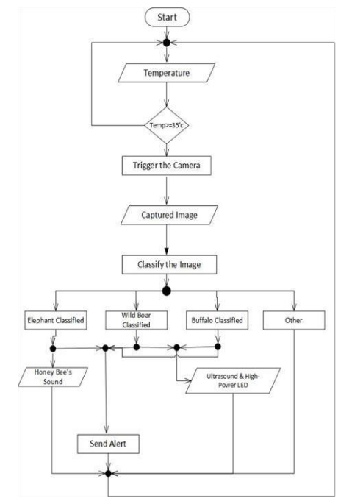

Fig:3.1 Flow chart of existing system

**IV.PROPOSED SYSTEM**

GSM module:

GSM or Global System for Mobile Communication is a Wireless Communication standard for mobile telephone systems. It was developed by the European Telecommunications Standards Institute (ETSI) as a replacement to the 1st Generation Analog Cellular Network.

Breadboard:

A breadboard, solderless breadboard, or protoboard is a construction base used to build semi-permanent  .

Compared to more permanent circuit connection methods, modern breadboards have high parasitic capacitance, relatively high resistance, and less reliable connections, which are subject to jostle and physical degradation. Signaling is limited to about 10 MHz, and not everything works properly even well below that frequency.

Connecting wires:

A connecting wire is represented by a straight line. It is usually made of copper and is provided with insulation to make electrical connections between two points.

Microchip:

A microchip is a small device implanted between the shoulder blades of an animal that is used for permanent identification. The microchip is about the size of a grain of rice and can be read by a microchip scanner. Each microchip contains a series of unique numbers similar to a vehicle VIN number.

Arduino uno:

The Arduino hardware and software was designed for artists, designers, hobbyists, hackers, newbies, and anyone interested in creating interactive objects or environments. Arduino can interact with buttons, LEDs, motors, speakers, GPS units, cameras, the internet, and even your smart-phone or your TV!

We need to connect these components as directed and connect GSM module to the users mobile.

We need to set the length of the object up to a certain length.

 The GSM Module with Arduino. There are different kinds of GSM modules available on the market. We are using the most popular module based on simcom SIM900 and arduino uno for this tutorial. Interfacing a GSM module to arduino is pretty simple. You only need to make 3 connections between the gsm module and arduino.

A GSM Module is basically a GSM Modem  (like SIM 900) connected to a PCB with different types of output taken from the board – say TTL Output (for Arduino, 8051 and other microcontrollers) and RS232 Output to interface directly with a PC (personal computer). The board will also have pins or provisions to attach the mic and speaker, to take out +5V or other values of power and ground connections. These types of provisions vary with different modules.

Lots of varieties of GSM modems and GSM Modules are available in the market to choose from. For our project of connecting a gsm modem or module to Arduino and hence sending and receiving SMS using Arduino – it’s always good to choose an Arduino compatible GSM Module – that is a GSM module with TTL Output provisions.

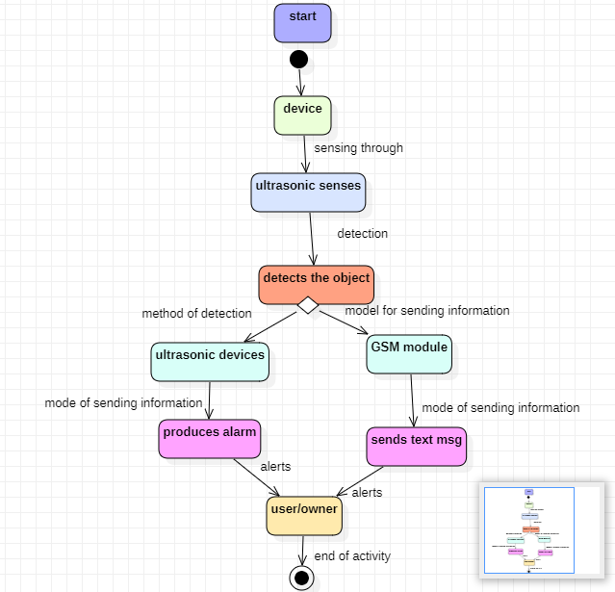

Fig: 4.1 Working of the system

The above diagram represents the working of the product designed where the device detects ultrasonic waves coming from the object and produces alarm in necessary conditions.

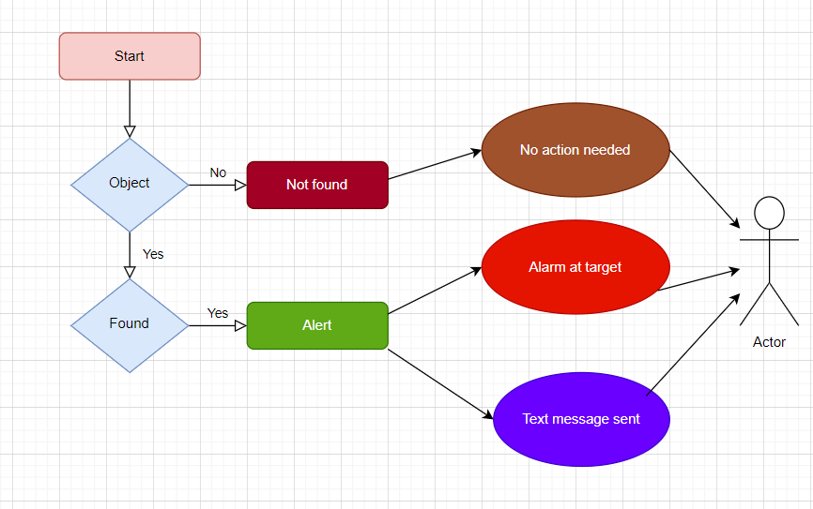

Fig: 4.2 Background activity of the system

**V.IMPLEMENTATION RESULTS**

This paper aims to detect objects coming near by the device set up i.e. ultrasonic sensor helps in detecting objects with least decibels that are closer to the targeted area. The GSM module is present in the device made in order to give the information to user in form of alarm or a text message in order to alert the user or the owner.

Battery efficiency:

Battery efficiency, simply put, is the amount of energy you can get out of a battery relative to the amount of energy that’s put into it.

The amount of energy you get out is always going to be less than what’s put in - however, there are specific factors that will affect that difference.

To overcome crop loss for the farmer from external sources will be enabled in this paper.

 

Fig:5.1 Pseudo Code

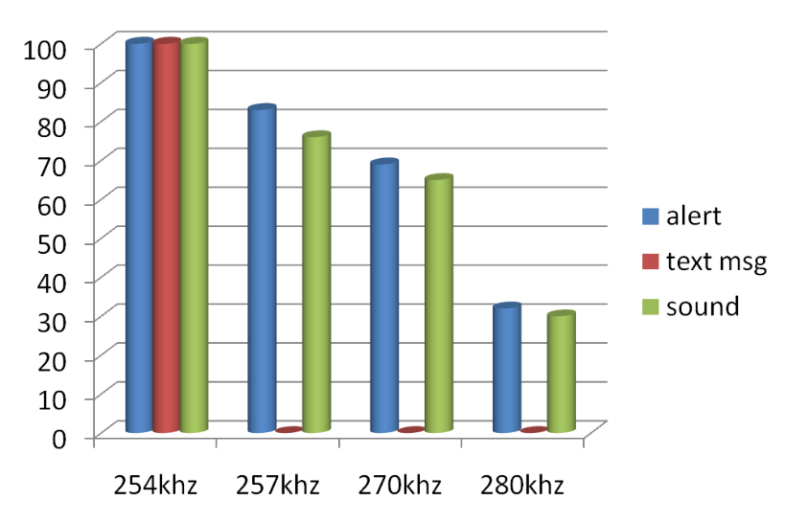

Fig:5.2 Alert Rates

The above graph represents the probability of alert rate of the implemented device and it describes percentage of alert when the sound is produced in certain frequency.

Fig:5.3Comparison Analysis

The above bar graph represents the accuracy of output when the distance varies.

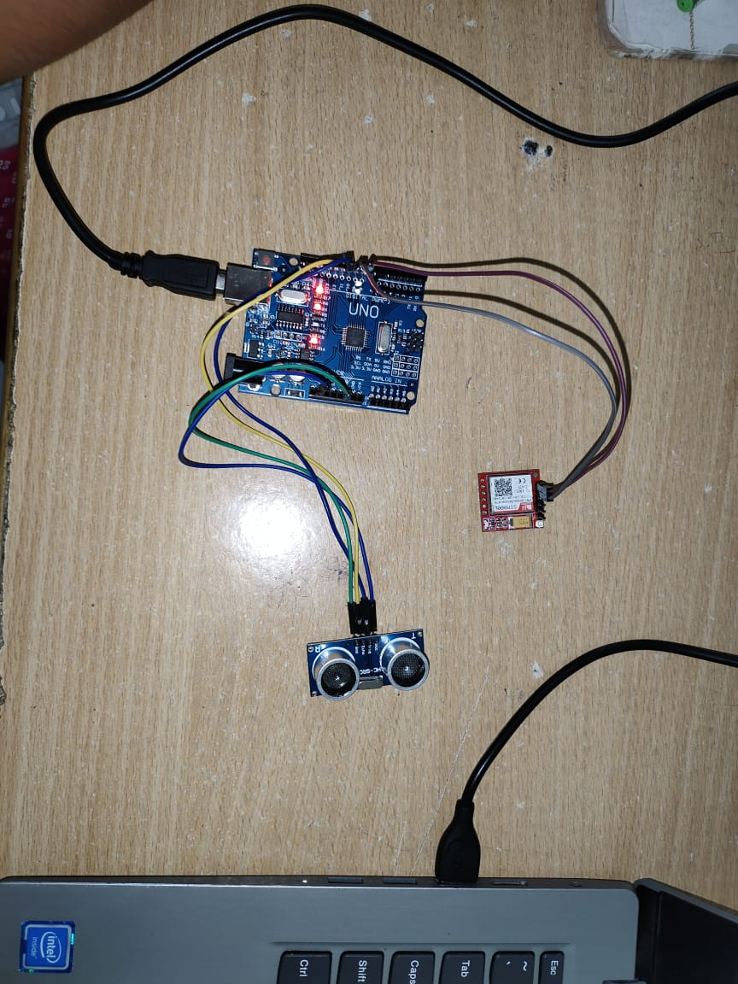

Fig: 5.3 System Setup

**VI.CONCLUSION**

There have been several reports of human-animal confrontations in the past, which have seriously harmed yielded crop and negatively impacted the economy and lead a great loss financially for the farmers. It is important to protect yielded crops from animals and to keep yield of crop safe.. For the purpose of detecting animals in crop yield regions and preventing human-animal conflicts, a real-time deep learning-based system has been proposed. Animals were automatically identified using object detection methods in machine learning and scared off by the sound produced with high pitch. The system has been put in place to accomplish three goals: spotting animals, keeping animals out of the yielded crop, producing high frequency alarm and alerting the user.

The device detects the presence of the objects coming nearby in the specified area mentioned in chip code. It alerts the user through a text message and produces sound as alarm near specified region using ultrasonic sound after sensing the object through ultrasonic sensor. The categorization model's output included a useful fright tactic, like a bee buzzing sound, ultrasound, or a quick burst of light. The farmer will also receive information about the animals via the mobile application at the same time. According to our research, the detecting system had an average accuracy of 72%.

**REFERENCES**

[1]M. Hnewa and H. Radha, "Object Detection Under Rainy Conditions for Autonomous Vehicles: A Review of State-of-the-Art and Emerging Techniques," in IEEE Signal Processing Magazine, vol. 38, no. 1, pp. 53-67, Jan. 2021.

[2]A. Raghunandan, Mohana, P. Raghav and H. V. R. Aradhya, "Object Detection Algorithms for Video Surveillance Applications," 2018 International Conference on Communication and Signal Processing (ICCSP), Chennai, India, 2018, pp. 0563-0568.

[3]Y. Tao, Z. Zongyang, Z. Jun, C. Xinghua and Z. Fuqiang, "Low-altitude small-sized object detection using lightweight feature-enhanced convolutional neural network," in Journal of Systems Engineering and Electronics, vol. 32, no. 4, pp. 841-853, Aug. 2021.

[4] B. J. Koskowich, M. Rahnemoonfai and M. Starek, "Virtualot — A Framework Enabling Real-Time Coordinate Transformation & Occlusion Sensitive Tracking Using UAS Products, Deep Learning Object Detection & Traditional Object Tracking Techniques," IGARSS 2018 - 2018 IEEE International Geoscience and Remote Sensing Symposium, Valencia, Spain, 2018, pp. 6416-6419.

[5] F. Amin, A. Mondal and J. Mathew, "A Large Dataset With a New Framework for Abandoned Object Detection in Complex Scenarios," in IEEE MultiMedia, vol. 28, no. 3, pp. 75-87, 1 July-Sept. 2021.

[6] Q. M. ul Haq, M. A. Haq, S. -J. Ruan, P. -J. Liang and D. -Q. Gao, "3D Object Detection Based on Proposal Generation Network Utilizing Monocular Images," in IEEE Consumer Electronics Magazine, vol. 11, no. 5, pp. 47-53, 1 Sept. 2022.

[7] N. A. OTHMAN, M. U. SALUR, M. KARAKOSE and I. AYDIN, "An Embedded Real-Time Object Detection and Measurement of its Size," 2018 International Conference on Artificial Intelligence and Data Processing (IDAP), Malatya, Turkey, 2018, pp. 1-4.

[8] A. E. Bilecen and H. Özkan, "Object-Centric Video Anomaly Detection with Covariance Features," 2022 30th Signal Processing and Communications Applications Conference (SIU), Safranbolu, Turkey, 2022, pp. 1-4.

[9] I. Kilic and G. Aydin, "Traffic Sign Detection And Recognition Using TensorFlow’ s Object Detection API With A New Benchmark Dataset," 2020 International Conference on Electrical Engineering (ICEE), Istanbul, Turkey, 2020, pp. 1-5.

[10] S. Zheng, J. Guo, H. Yue and X. Liu, "Cross Domain Edge Detection Based Label Decoupling Salient Object Detection," 2021 IEEE 21st International Conference on Communication Technology (ICCT), Tianjin, China, 2021, pp. 1143-1147.

[11] J. Li, P. Yuan, D. Gu and Y. Tian, "Hierarchical Deep Cosegmentation of Primary Objects in Aerial Videos," in IEEE MultiMedia, vol. 26, no. 3, pp. 9-18, 1 July-Sept. 2019.

[12] L. Fu, H. Yu, X. Li, C. P. Przybyla and S. Wang, "Deep Learning for Object Detection in Materials-Science Images: A tutorial," in IEEE Signal Processing Magazine, vol. 39, no. 1, pp. 78-88, Jan. 2022.

[13] X. Wu, W. Li, D. Hong, R. Tao and Q. Du, "Deep Learning for Unmanned Aerial Vehicle-Based Object Detection and Tracking: A survey," in IEEE Geoscience and Remote Sensing Magazine, vol. 10, no. 1, pp. 91-124, March 2022.

[14] G. Srivastava and R. Srivastava, "Modification of Gradient Vector Flow Using Directional Contrast for Salient Object Detection," in IEEE MultiMedia, vol. 26, no. 4, pp. 7-16, 1 Oct.-Dec. 2019.

[15]L. Zhang, J. Zheng, R. Sun and Y. Tao, "GC-Net: Gridding and Clustering for Traffic Object Detection With Roadside LiDAR," in IEEE Intelligent Systems, vol. 36, no. 4, pp. 104-113, 1 July-Aug. 2021.

[16] D. Mohanapriya and K. Mahesh, "Multi object tracking using gradient-based learning model in video-surveillance," in China Communications, vol. 18, no. 10, pp. 169-180, Oct. 2021.

[17] F. Amin, A. Mondal and J. Mathew, "A Large Dataset With a New Framework for Abandoned Object Detection in Complex Scenarios," in IEEE MultiMedia, vol. 28, no. 3, pp. 75-87, 1 July-Sept. 2021.

### [18] W. Han et al., "Methods for Small, Weak Object Detection in Optical High-Resolution Remote Sensing Images: A survey of advances and challenges," in IEEE Geoscience and

### Remote Sensing Magazine, vol. 9, no. 4, pp. 8-34, Dec. 2021.

[19] M. Hnewa and H. Radha, "Object Detection Under Rainy Conditions for Autonomous Vehicles: A Review of State-of-the-Art and Emerging Techniques," in IEEE Signal Processing Magazine, vol. 38, no. 1, pp. 53-67, Jan. 2021.

[20] Q. M. ul Haq, M. A. Haq, S. -J. Ruan, P. -J. Liang and D. -Q. Gao, "3D Object Detection Based on Proposal Generation Network Utilizing Monocular Images," in IEEE Consumer Electronics Magazine, vol. 11, no. 5, pp. 47-53, 1 Sept. 2022.

A. Jain et al. [21] A. Jain et al., "AI-Enabled Object Detection in UAVs: Challenges, Design Choices, and Research Directions," in IEEE Network, vol. 35, no. 4, pp. 129-135, July/August 2021.

[22] H. Wang, Y. Yu, Y. Cai, X. Chen, L. Chen and Q. Liu, "A Comparative Study of State-of-the-Art Deep Learning Algorithms for Vehicle Detection," in IEEE Intelligent Transportation Systems Magazine, vol. 11, no. 2, pp. 82-95, Summer 2019.

[23] C. Tung et al., "Why Accuracy is Not Enough: The Need for Consistency in Object Detection," in IEEE MultiMedia, vol. 29, no. 3, pp. 8-16, 1 July-Sept. 2022.

[24] Z. Gao et al., "Salient Object Detection in the Distributed Cloud-Edge Intelligent Network," in IEEE Network, vol. 34, no. 2, pp. 216-224, March/April 2020.

[25] X. Jiang, F. R. Yu, T. Song and V. C. M. Leung, "Edge Intelligence for Object Detection in Blockchain-Based Internet of Vehicles: Convergence of Symbolic and Connectionist AI," in IEEE Wireless Communications, vol. 28, no. 4, pp. 49-55, August 2021.

[26] X. Tang, Z. Zhang and Y. Qin, "On-Road Object Detection and Tracking Based on Radar and Vision Fusion: A Review," in IEEE Intelligent Transportation Systems Magazine, vol. 14, no. 5, pp. 103-128, Sept.-Oct. 2022.

[27] S. -W. Kim, K. Ko, H. Ko and V. C. M. Leung, "Edge-Network-Assisted Real-Time Object Detection Framework for Autonomous Driving," in IEEE Network, vol. 35, no. 1, pp. 177-183, January/February 2021.

[28] S. M. D. Rizvi, S. Ahmad, K. Khan, A. Hasan and A. Masood, "Deep Learning Approach for Fixed and Rotary-Wing Target Detection and Classification in Radars," in IEEE Aerospace and Electronic Systems Magazine, vol. 37, no. 3, pp. 32-42, 1 March 2022.

[29] Y. Sahraoui, C. A. Kerrache, A. Korichi, B. Nour, A. Adnane and R. Hussain, "DeepDist: A Deep-Learning-Based IoV Framework for Real-Time Objects and Distance Violation Detection," in IEEE Internet of Things Magazine, vol. 3, no. 3, pp. 30-34, September 2020.

[30] H. Chen, Z. Wang and L. Zhang, "Collaborative spectrum sensing for illegal drone detection: A deep learning-based image classification perspective," in China Communications, vol. 17, no. 2, pp. 81-92, Feb. 2020.

1. JKR Sastry and M. Lakshmi Prasad, “Testing Embedded System through Optimal Mining Technique (OMT) Based on Multi-Input Domain,” International Journal of Electrical and Computer Engineering Vol. No.9 Issue No.3, pp.no.2141-2150, 2019 (Scopus).
2. J.Sasi Bhanu,Dr. JKR Sastry and Dr.M. Lakshmi Prasad, "Testing Embedded Systems from Multi-Output Domain Perspective", International Journal of Recent Technology and Engineering.
3. Dr.M. Lakshmi Prasad, Dr.A.Rajasekhar Reddy and Dr. JKR Sastry, "GAPSO: Optimal Test Set Generator for Pair wise Testing", International Journal of Engineering and Advanced Technology , Vol-8 Issue-6 , Aug-19.
4. M. Lakshmi Prasad and Dr. JKR Sastry, “A Neural Network Based Strategy (NNBS) For Automated Construction of Test Cases for Testing an Embedded System Using Combinatorial Techniques,” International Journal of Engineering Technology Vol. No.7 Issue No.1, pp.no.74-81, Jan 2018 (Scopus).
5. J.Sasi Bhanu ,M. Lakshmi Prasad and Dr. JKR Sastry, “Testing Embedded System through Optimal Combinatorial Mining Technique,” Journal of Advanced Research in Dynamical and Control Systems, Vol. 10, 07-Special Issue, pp.no.337-354, June 2018 (Scopus).
6. J.Sasi Bhanu ,M. Lakshmi Prasad and Dr. JKR Sastry, “Combinatorial Neural Network Based Testing of an Embedded System,” Journal of Advanced Research in Dynamical and Control Systems, Vol. 10, 07-Special Issue, pp.no.605-616, June 2018 (Scopus).
7. J.Sasi Bhanu,M. Lakshmi Prasad and Dr. JKR Sastry, “Testing Embedded Systems Using a Graph Based Combinatorial Method (GBCM),” Journal of Advanced Research in Dynamical and Control Systems, Vol. 10, 07-Special Issue, pp.no.355-375, June 2018 (Scopus).
8. J.Sasi Bhanu ,M. Lakshmi Prasad and Dr. JKR Sastry, “A Combinatorial Particle Swarm Optimization (PSO) for Testing an Embedded Systems,” Journal of Advanced Research in Dynamical and Control Systems, Vol. 10, 07-Special Issue, pp.no.321-336, June 2018 (Scopus).
9. M. Lakshmi Prasad ; J.Kodanda Rama Sastry ; Basetty Mallikarjuna, “Development of a Programmed Generation of t-way Test cases Using an Improved Particle Swarm Optimization Strategy”,2022 2nd International Conference on Advance Computing and Innovative Technologies in Engineering (ICACITE) ,28-29 April 2022 .
10. Lakshmiprasad, M.; Sreenivasulu, Ch.; Bojja, Polaiah; Kodanda Rama Sastry, J.; Alekhay, V., “A Reactive Approach for Predicting Accident Black Spots Using IOT and Machine Knowledge.”, International Journal of Early Childhood Special Education . 2022, Vol. 14 Issue 8, p235-244. 10p.
11. M. Lakshmiprasad, et al., “Adaptive framework for detecting Accident black spots using IoT and Machine Learning”. Design Engineering, 5422 – 5428,2021.
12. .Polaiah Bojja et al,, A Dynamic Optimization And Deep Learning Technique For Detection Of Lung Cancer In Ct Images And Data Access Through Internet Of Things, Springer Wireless Personal Communications On April 06, 2022.
13. .Polaiah Bojja et al., Industrial Iot Enabled Fuzzy Logic Based Flame Image Processing ForRotary Kiln Control, Springer Wireless Personal Communications, April 06, 2022.
14. Reddy, C. Kishor Kumar, P. R. Anisha, and LV Narasimha Prasad. "A novel approach for detecting the bone cancer and its stage based on mean intensity and tumor size." Recent Researches in Applied Computer Science 20.1 (2016): 162-171.
15. Prasad, Narasimha, and Mannava Munirathnam Naidu. "Gain ratio as attribute selection measure in elegant decision tree to predict precipitation." 2013 8th EUROSIM Congress on Modelling and Simulation. IEEE, 2013.